HDLC Frame

🧱 What Is an HDLC Frame?
# Source: AI Source: Provided by: [Data Path: Persons Table -> ID Column: 1, Name_En Column: Motasem Essam] -> From: [ChatGPT] on [1/16/2026]
HDLC (High-Level Data Link Control) is a Layer 2 (Data Link Layer) protocol used to transmit data reliably over point-to-point and multipoint links. It is a bit-oriented synchronous protocol developed by ISO and commonly used in WANs and serial interfaces (e.g., routers).
An HDLC frame is the standard format used by HDLC to encapsulate data — ensuring proper delivery, sequencing, and error detection.

🧠 Simple Definition:
# Source: AI Source: Provided by: [Data Path: Persons Table -> ID Column: 1, Name_En Column: Motasem Essam] -> From: [ChatGPT] on [1/16/2026]
An HDLC frame is a structured data unit used to encapsulate packets for transmission over synchronous serial links, ensuring reliable communication between two or more devices.

🧾 HDLC Frame Format
# Source: AI Source: Provided by: [Data Path: Persons Table -> ID Column: 1, Name_En Column: Motasem Essam] -> From: [ChatGPT] on [1/16/2026]
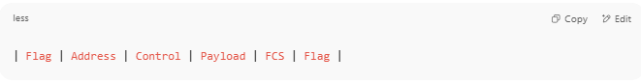
| Flag | Address | Control | Payload | FCS | Flag |

🔍 HDLC Frame Field Breakdown
# Source: AI Source: Provided by: [Data Path: Persons Table -> ID Column: 1, Name_En Column: Motasem Essam] -> From: [ChatGPT] on [1/16/2026]
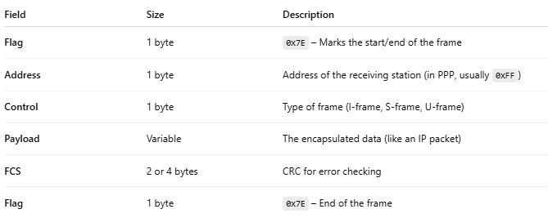
Field | Size | Description
Flag | 1 byte | 0x7E – Marks the start/end of the frame
Address | 1 byte | Address of the receiving station (in PPP, usually 0xFF)
Control | 1 byte | Type of frame (I-frame, S-frame, U-frame)
Payload | Variable | The encapsulated data (like an IP packet)
FCS | 2 or 4 bytes | CRC for error checking
Flag | 1 byte | 0x7E – End of the frame

📂 Types of HDLC Frames
# Source: AI Source: Provided by: [Data Path: Persons Table -> ID Column: 1, Name_En Column: Motasem Essam] -> From: [ChatGPT] on [1/16/2026]
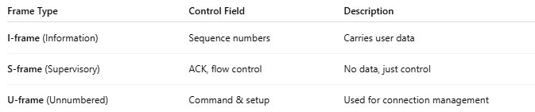
Frame Type | Control Field | Description
I-frame (Information) | Sequence numbers | Carries user data
S-frame (Supervisory) | ACK, flow control | No data, just control
U-frame (Unnumbered) | Command & setup | Used for connection management

🧠 Visual Example – HDLC Frame
# Source: AI Source: Provided by: [Data Path: Persons Table -> ID Column: 1, Name_En Column: Motasem Essam] -> From: [ChatGPT] on [1/16/2026]
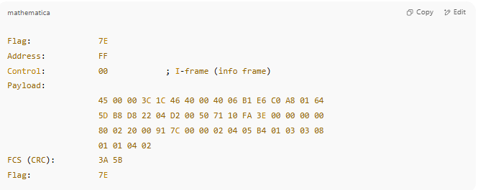
Flag: 7E
Address: FF
Control: 00 ; I-frame (info frame)
Payload:
45 00 00 3C 1C 46 40 00 40 06 B1 E6 C0 A8 01 64
5D B8 D8 22 04 D2 00 50 71 10 FA 3E 00 00 00 00
80 02 20 00 91 7C 00 00 02 04 05 B4 01 03 03 08
01 01 04 02
FCS (CRC): 3A 5B
Flag: 7E

🆚 HDLC vs PPP
# Source: AI Source: Provided by: [Data Path: Persons Table -> ID Column: 1, Name_En Column: Motasem Essam] -> From: [ChatGPT] on [1/16/2026]
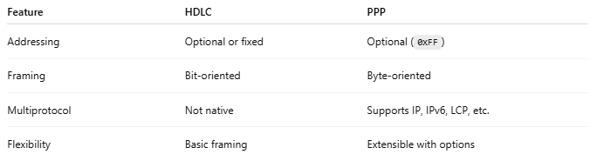
Feature | HDLC | PPP
Addressing | Optional or fixed | Optional (0xFF)
Framing | Bit-oriented | Byte-oriented
Multiprotocol | Not native | Supports IP, IPv6, LCP, etc.
Flexibility | Basic framing | Extensible with options

✅ Summary
# Source: AI Source: Provided by: [Data Path: Persons Table -> ID Column: 1, Name_En Column: Motasem Essam] -> From: [ChatGPT] on [1/16/2026]
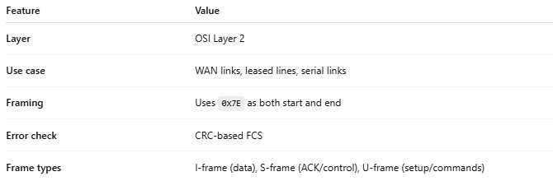
Feature | Value
Layer | OSI Layer 2
Use case | WAN links, leased lines, serial links
Framing | Uses 0x7E as both start and end
Error check | CRC-based FCS
Frame types | I-frame (data), S-frame (ACK/control), U-frame (setup/commands)

